Chapter 18, Problem 69.

A signal with Fourier transform

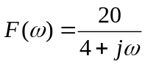

is passed through a filter whose cutoff frequency is 2 rad/s (i.e., 0 < ω < 2). What fraction of the energy in the input signal is contained in the output signal?

